MGLEP Program description

MGLEP
(Master’s Program for Future Global Leaders in Environmental Policy)

Batch 13

February 2027 ~ December 2028
Seoul, Republic of Korea




TABLE OF CONTENTS

1. OVERVIEW | 3
2. PROGRAM DESCRIPTION | 3
3. APPLICATION ELIGIBILITY | 4
4. SCHOLARSHIP BENEFIT | 4
5. METHOD OF APPLICATION | 5
6. APPLICATION PROCEDURE | 5
7. Application Timeline | 6
8. ADDITIONAL INFORMATION | 6
9. HOW TO APPLY TO MGLEP | 7

Master’s Program for Future Global Leaders
in Environmental Policy (MGLEP)

1. OVERVIEW
The Master’s Program for Future Global Leaders in Environmental Policy (MGLEP) funded by the Ministry of Environment of Korea is a scholarship program designed to provide the prospective leaders of partner countries with an opportunity to pursue graduate studies in Environmental Policy at a prestigious school in Korea. The program encourages participants to enhance their knowledge and experience through courses, study trips and internship aiming at developing and managing public policies on sustainable development. The program also supports the participants to build and strengthen cooperative networks with one another, environmental policy experts and governments officials in Korea. The program provides the full-ride scholarship with a monthly living allowance to help the participants to focus on the study.

2. PROGRAM DESCRIPTION
Program Offered: Master’s Program for Future Global Leaders in Environmental Policy (MGLEP)
Purpose:
▪ To provide an opportunity for prospective leaders of countries that have close ties with Korea;
to pursue graduate studies in Environmental Policy at a designated academic institution in Korea; to
contribute to sustainable economic and social development of our partner countries
▪ To share our experience on development practices in order to promote cooperation
among partner countries.
Sponsor: Korean Government (Ministry of Environment)
Stakeholders:
▪ Ministry of Environment(KME): Design the program and provide fund
▪ International Cooperation & Exhibition Team from Korea Environmental Conservation Institute(KECI) : Manage and coordinate the program, Provide extra programs(networkings, internship,. etc)
▪ Academic Institution : Provide coursework and extra-curricular programs, and support the participants’ settlement
Curriculum:
▪ Commonly required courses: Courses about Korea’s Environmental Policy, Environmental Seminars
and Field Trips
▪ Major required and selective courses: Depend on academic institution’s curriculum
▪ Extracurricular courses: Korean Language and Culture
Academic institution: University of Seoul (UOS)
Language: English
Duration: Feb. 2026 – Dec. 2027 (2 years in maximum to obtain a Master’s Degree)

3. APPLICATION ELIGIBILITY
To be eligible, candidates must satisfy the followings:
- Be citizens of the partnering countries designated by the Ministry of Environment of the Republic of Korea
- Be government officials or public sectors’ employees whose work is closely related to environmental policies or sustainable development (more than three years of experience required, permanent employees only).
For employees of public organizations and institutions nominated by their governments,
a letter of nomination from the Ministry concerned as well as the organization where an applicant belongs are both required.
- Hold a Bachelor’s degree officially recognized by the government concerned as of the date of arrival to Korea
- Have a good command of both spoken and written English
- Not have participated in any of the Korean government’s scholarship programs (Master’s degree or higher) before
- Official English test score required and must be submitted(e.g., TOEIC, TOEFL, IELTS, etc.)
- Have adequate health, both mentally and physically, to stay in a Korea for an extended period of time (under the age of 40 years preferred)
- Agree to return to their home country after the completion of the program
- Meet the selection criteria of an academic institution

4. SCHOLARSHIP BENEFIT (What does the scholarship cover?)
Full-ride scholarship with a monthly stipend is provided. The following expenses are included in the details of financial support by MGLEP.
- Tuition fee
- Accommodation (dormitory of academic institution)
- Living allowance (including meals): KRW 999,000 per month
- Travel expenses (airfare): Round-trip economy class ticket
- Miscellaneous travel expenses: KRW 200,000 upon arrival / KRW 300,000 when departure
- Korean Language class: full coverage
- Textbooks and materials: distributed by a designated university
- Extracurricular activities such as study and field trips during the program
- Medical checkup, twice during the period
- Insurance

5. METHOD OF APPLICATION
The Ministry of Environment of the Republic of Korea(KME) requests environment-related
organizations of Korea’s partner countries to recommend eligible candidates for the program.
Applicants should submit all documents related to their scholarship application to University of Seoul (UOS), which will be provided with the Program Discription.
※ URL : www.mglep.net/apply

6. APPLICATION PROCEDURE

step 1 |  | MCEE invites partner countries to recommend eligible candidates. |  | Sep. 2026
step 2 |  | Applicants send documents to University of Seoul (by online).  ※ www.mglep.net/apply |  | By Oct. 30. 2026
step 3 |  | An Academic institution reviews the submitted documents.  ※ If necessary, we can ask your affiliated institution to confirm the authenticity of the document you submitted. |  | By Nov.13. 2026
step 4 |  | An academic institution informs the result of document review and coordinates the online interview schedule. |  | By Nov.18. 2026
step 5 |  | An academic institution conducts an online interview. |  | Nov. 23 -27, 2026
step 6 |  | The MCEE, the KECI and an academic institution select scholarship recipients based on selection criteria. |  | Dec.30. 2026
step 7 |  | The KECI notifies the selected scholarship recipients of officially accepted for the program. |  | By Jan. 2027
step 8 |  | Selected scholarship recipients arrive in Korea. |  | Feb , 2027
 | ※ Please note that the dates are subject to change. All dates are in Korean Standard Time (KST)

7. Application Timeline
Application & Registration Schedule

Procedure | Admission Schedule for Spring 2026
Application deadline | By October. 30, 2026
Document Review | By November. 13, 2026
Online Interview | November. 23 – 27, 2026
Final Admission Decision | By December. 30, 2026
Deliver a letter of acceptance | By January, 2027
Arrival in Korea | Feb , 2027
※ The dates are subject to change. All dates are in Korean Standard Time (KST).

8. ADDITIONAL INFORMATION
· Submission of Documents : The required documents should be submitted at the University of Seoul, International School of Urban Sciences office by online no later than the application deadline. (Korean Standard Time (KST))
· English Proficiency Score Report : All applicants are required to submit a valid official English proficiency test score.(TOEIC, TOEFL, IELTS, etc.)
· Language : All of courses are conducted entirely in English. Therefore, an online interview for applicants who have passed the documents review is conducted in English. The online interview is mandatory for nominated as a scholarship recipient.
· No deferral : An offer of admission to the program is made only for the upcoming academic year. Acceptance of the offer cannot be deferred.
· Dormitory : Dormitory residence is mandatory for all MGLEP participants. Participants should stay in the dormitory provided by his/her academic institution.
· Not allowed to bring family members : As MGLEP is an intensive program which requires participants of full commitment and concentrated endeavors for studying, participants are not allowed to bring any family members.

9. HOW TO APPLY TO MGLEP
· Submission documents
★ Please submit all documents in English. (①~⑬)
*Documents in any other language should be accompanied by a notarized English translation.
★ All forms should be completed in typed. (①~⑤, ⑫)
*After completing the documents, you have to submit it online(www.mglep.net).
Please refer to How to submit applications.
★ Applicants must submit either the apostilled or embassy notarized document. (⑧~⑪)

- (Form 1) MGLEP Application Form
- (Form 2) Personal Statement
- (Form 3) Study Plan
- (Form 4) A Letter of Recommendation
- (Form 5) Letter of Nomination from the Ministry or Organization of the applicant’s affiliation
★ Please submit the Nomination letter signed by the head of your organization
1) the Minister of the Ministry
2) the Head of the Organization of the Applicant’s Affiliation
★ If you aren’t officially nominated by your organization, it may be difficult to accept your application.
- (Form 6) Applicants must submit Participant’s Guideline provided by University of Seoul
- Certificate of Graduation of Undergraduate and Graduate school (Apostilled or Embassy Notarized)
- Official Transcripts of undergraduate and graduate schools (Apostilled or Embassy Notarized)
- Official Report of English-Proficiency Test (TOEFL/TOEIC/IELTS) or any proof of applicant’s English-Proficiency. Applicants from countries where English is considered as one of an official language are exempt from submitting an English proficiency test score (Apostilled or Embassy Notarized).
- Certificate of Employment (Apostilled or Embassy Notarized)
★ Please prove that you have worked for more than three years as a full-time or permanent employee.
★ Certificate of employment should include particular words such as permanent or full-time.
- Curriculum Vitae
- A Copy of Passport (If the passport has yet to be issued, please send a photocopy of national ID card. As soon as the passport is issued, please send a copy of the passport)
- Two photos, 3X4 cm or passport size

· How to submit applications
★ You can submit the application online(www.mglep.net) by October 30.
★ After October 30 the homepage submission system will be blocked automatically.
step 1 |  | · Type and fill out application forms.  · Prepare all requirements for submission.  *All forms should be completed in English and typed.
step 2 |  | · Create your own account before signing in.  * Web address : www.mglep.net  - Input www.mglep.net on the web browser. (Chrome is strictly recommended.)  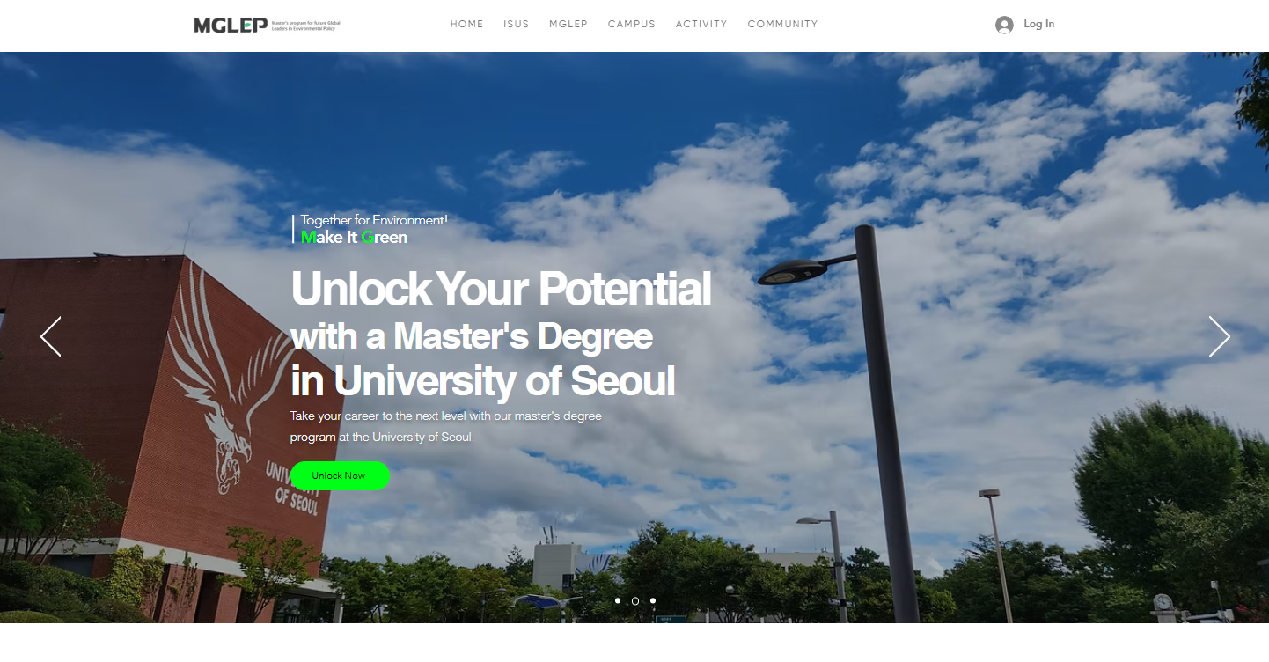  - Click Create account or use gmail to sign in  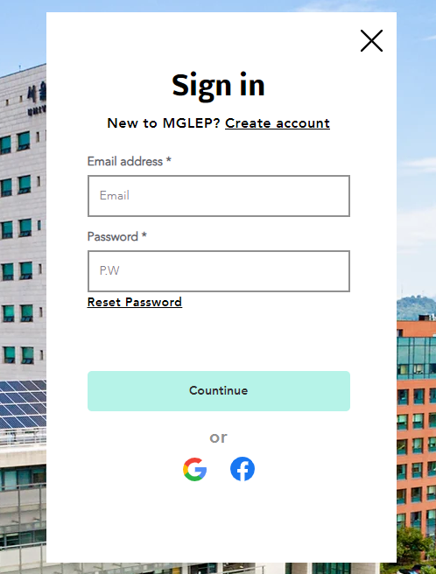  - When creating an account, please fill out your information  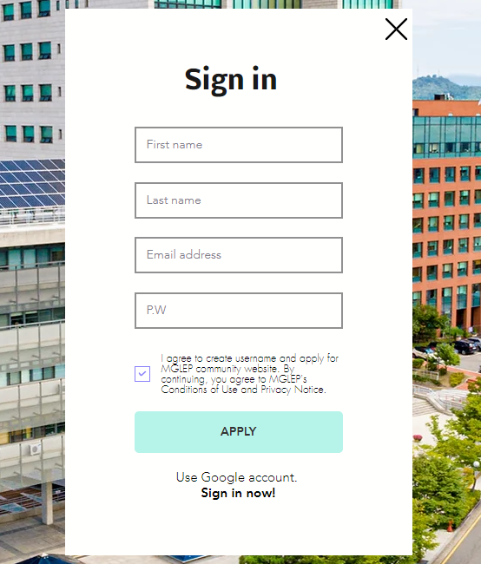  - Don’t forget your password.  *There is no section to confirm the password
step 3 |  | · How to sign in  · Type in your info and Click APPLY button  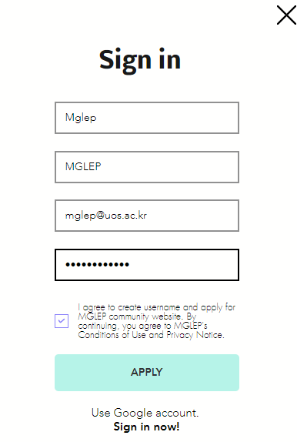
step 4 |  | · Submit documents for MGLEP 13  - After log in, click APPLY NOW  - Or you can use link: www.mglep.net/apply  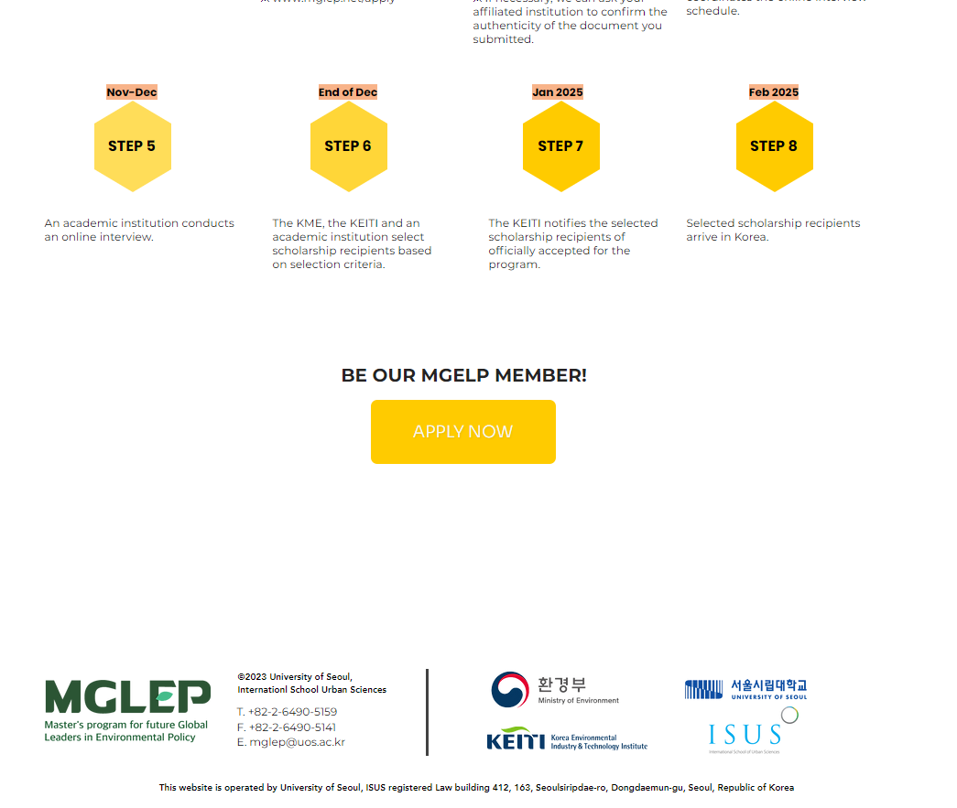
step 5 |  | · Enroll in MGLEP Course  - Please read all instruction on the website  - Also download and read Program Description and infomation  - Download Application Checklist and Form 1~6  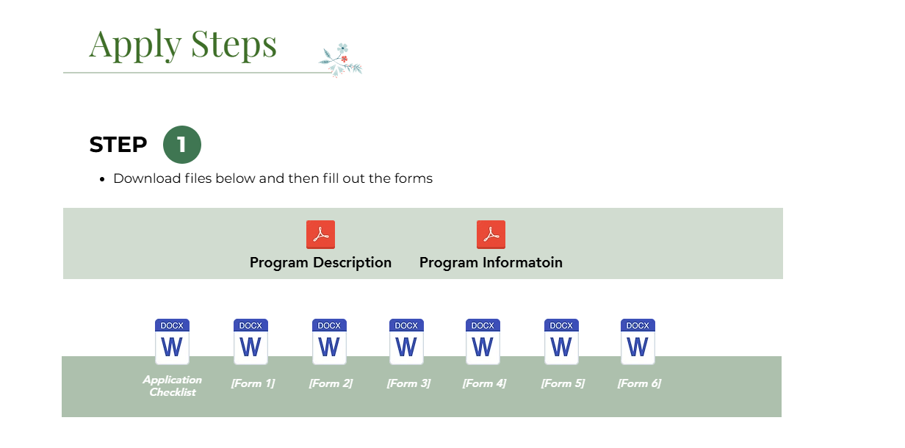
step 6 |  | · Click Upload & Apply on the bottom  - After reading the instruction, prepare all the documents. Must be typed.  - Click Upload & Apply  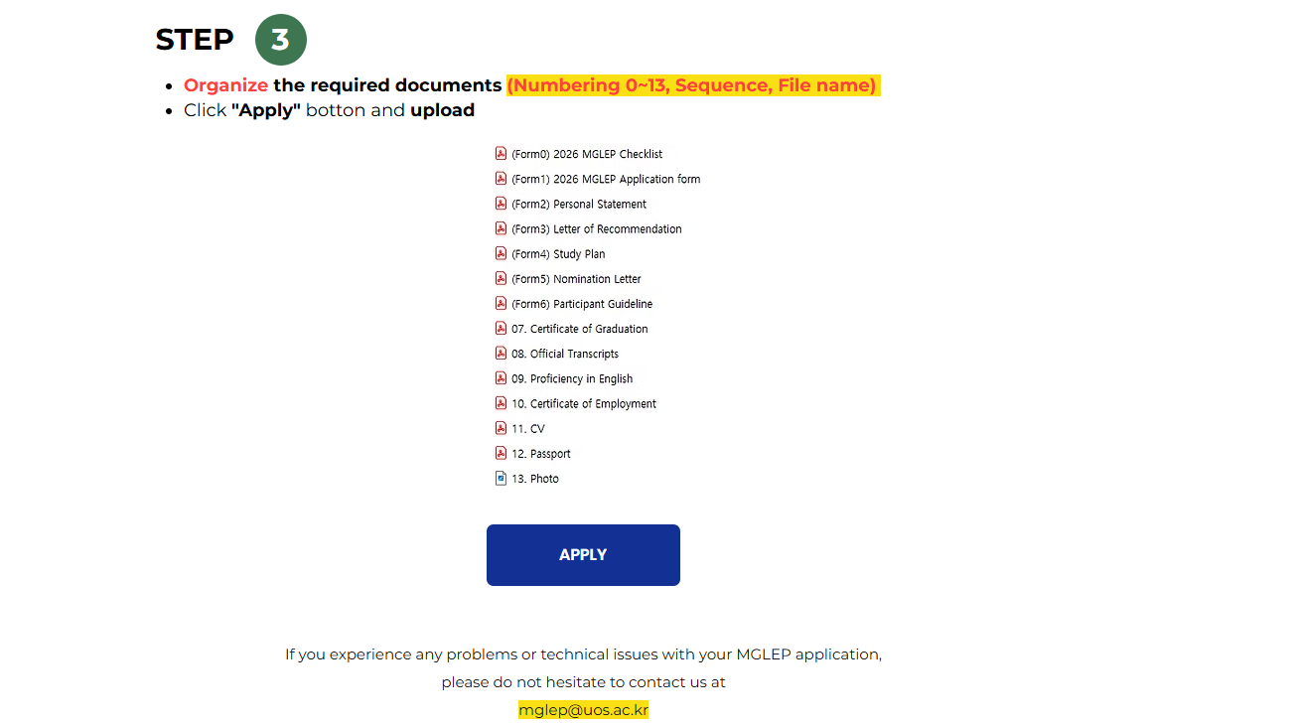
step 7 |  | · Fill out your information  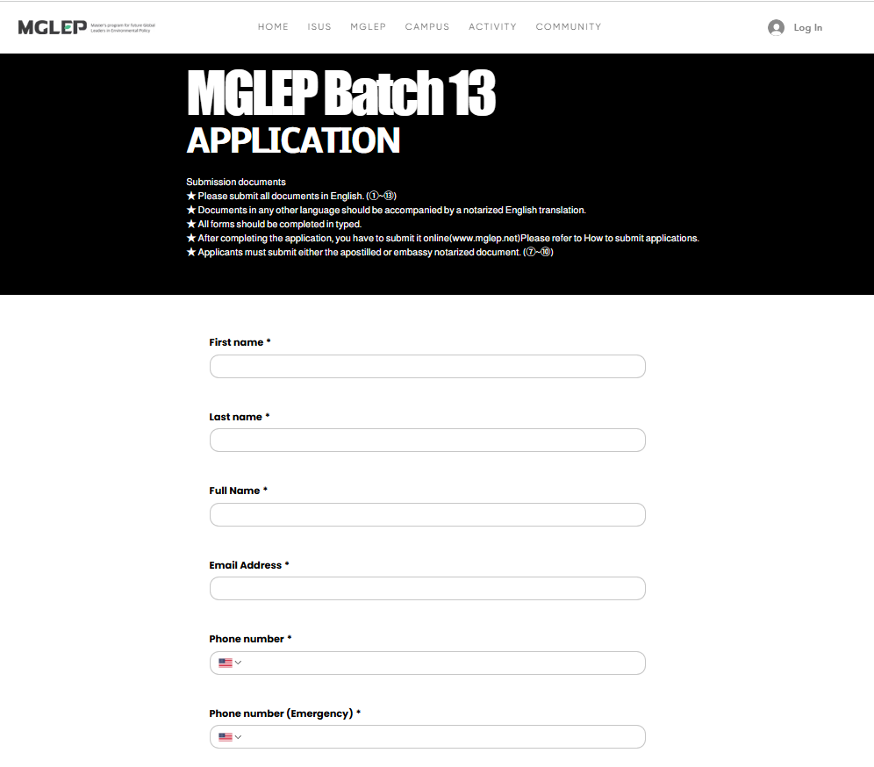
step 8 |  | · Upload Appliction Checklist and Form 1~6  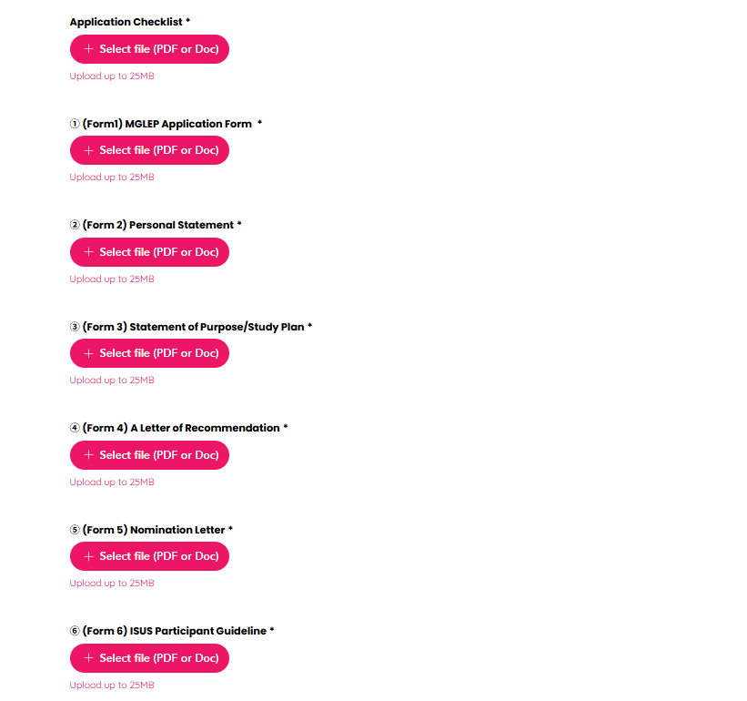
step 9 |  | · Form 7 ~ 13  - Please upload documents ⑦~⑬  - If you cannot upload these documents before the deadline due to the document process in your country, please email us the reason and an estimated date of the submission. mglep@uos.ac.kr  - An estimated date of the submission must be before October 30th.  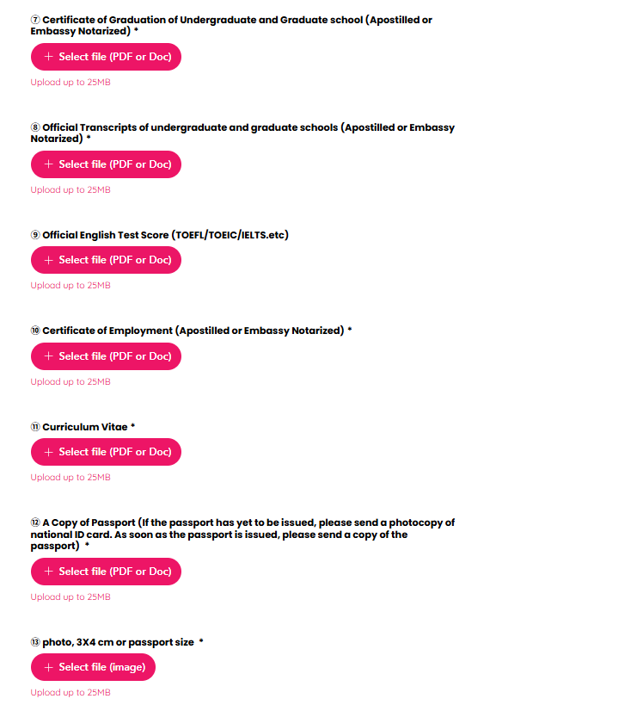
step 10 |  | · If you have uploaded all documents from 1 to 13, please click the “Apply” button to complete the submission.    · After checking the documents, we can request you for supplementary.
Important Notes |  | · We kindly inform you in advance if you don’t submit all required documents except official report of English-proficiency test, your application may not be accepted.  · If the submission of your official English test score is delayed, you may submit it separately via email before the completion of the document screening period.  · If any of the submitted materials contain false information, admission will be rescinded.  · There will be procedures to verify the authenticity of the document.  · If you cannot submit the document due to website error, please contact us by the following email.  E-mail : mglep@uos.ac.kr
Step 11 |  | · Selected applicants have to submit original documents to University of Seoul.  - Submit it by mail from your country or  - When you come to Korea, you can bring it and submit it to the school.  (All selected applicants are required to submit the original document.)  Address : International School of Urban Sciences, University of Seoul  #20-412, Law School Building, 163 Seoulsiripdae-ro, Dongdaemun-gu,  Seoul, Republic of Korea  서울시립대학교 국제도시과학대학원  서울특별시 동대문구 서울시립대로 163 법학관 20-412호  (02504)  Receiver : Sharon Beak  Postal Code : 02504

※ You can find more details at

www.mglep.net/mglep
* Create your own account before signing in

For more information, please contact:

❏ International School of Urban Sciences (ISUS), University of Seoul
Phone: +82-2-6490-5159 / +82-2-6490-5140 / +82-2-6490-5157
Fax: +82-2-6490-5141
E-mail: mglep@uos.ac.kr
Home page:
-ISUS Homepage: isus.uos.ac.kr
-MGLEP Homepage: www.mglep.net
Address: #412, Law School, University of Seoul,
163, Seoulsiribdae-ro, Dongdaemun-gu, Seoul,
Republic of Korea, 02504

