Program Information

2027 - 2028
UNIVERSITY OF SEOUL

Master’s Program for Future Global Leaders in Environmental Policy
(MGLEP)

February 2027 ~ December 2028
Seoul, Republic of Korea





CONTENTS

TABLE OF CONTENTS

PART 0. SCHOLARSHIP PROGRAM & KECI 01
PART I. WELCOME MESSAGE 02
PART II. PROGRAM OVERVIEW 05
PART III. HOW TO APPLY 07
1. APPLICATION/ADMISSION PROCEDURE 07
PART IV. PROGRAM CONTENTS 09
1. ACADEMIC SCHEDULE 09
2. CURRICULUM 11
3. EXTRACURRICULAR ACTIVITIES 13
PART V. ACADEMIC INSTITUTION 14
1. GENERAL OVERVIEW OF UOS 14
2. INTERNATIONAL SCHOOL OF URBAN SCIENCES (ISUS) 15
3. ACCOMMODATION 16
4. OTHER INFORMATION 19
PART VI. SUPPORT SERVICE 27
1. TRAVEL TO KOREA 27
2. EXPENSES FOR STUDY AND LIVING 27
3. MEDICAL SUPPORT AND INSURANCE 28
PART VII. REGULATIONS 30
1. PARTICIPANT’S RESPONSIBILITIES 30
2. WITHDRAWALS 31
3. TEMPORARY LEAVE 31
4. ACCOMPANYING OR INVITING FAMILY 32
5. OTHERS 32
PART VIII. CONTACTS 33

Master’s Program for Future Global Leaders in Environmental Policy (MGLEP)

The Master’s Program for Future Global Leaders in Environmental Policy (MGLEP), funded by the Ministry of Climate, Energy and Environment (MCEE), is designed to support a graduate studies program for government officials working in environmental or related fields in Korea’s partner countries.
The main goal of MGLEP is to train key personnel with the capacity to lead sustainable economic and social development in our partner countries by sharing Korea’s know-how and experience in environmental improvement.
MCEE launched the program in 2015 in response to demand from its partner countries for long-term capacity-building programs discussed during high-level meetings and through the Ministry’s international cooperation network.
The program aims to contribute to capacity-building in environmental policy in partner countries by enabling participants to experience Korea’s development process, gain specialized knowledge in the environmental field through intensive training, and strengthen their ability to develop and analyze policy.
As the host of the program, MCEE will make its best effort to support MGLEP participants not only in expanding their knowledge of environmental policy and technology, but also in building valuable networks and experiencing Korean culture, society, and history through this invitation program for officials from our partner countries.

International Cooperation & Exhibition Team of
Korea Environmental Conservation Institute (KECI)

The Korea Environmental Conservation Institute (KECI), a public institution under the Ministry of Environment, was officially rebranded from the former Korea Environmental Preservation Association in June 2023, pursuant to the Framework Act on Environmental Policy originally enacted in 1978. KECI serves as a specialized agency committed to advancing environmental conservation through a range of strategic initiatives.
The International Cooperation & Exhibition Team at KECI promotes inclusive and systematic environmental education under the vision of “a learning society for the environment.” The team supports policy implementation, develops customized programs, enhances educator capacity, operates certification systems, and fosters nationwide networks to cultivate environmentally responsible citizens.
Under the vision of “a global green partnership platform for a sustainable future,” KECI also manages the Master’s Program for Future Global Leaders in Environmental Policy. This graduate-level program is designed for foreign government officials and aims to share Korea’s environmental knowledge and experiences while strengthening long-term international partnerships.

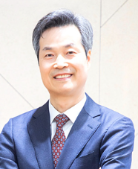
The Leading Education & Research Institution
in Urban Sciences

Yongkul WON
President, University of Seoul
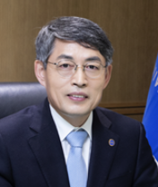
The University of Seoul, founded in 1918, has long been committed to providing higher education opportunities for intelligent, motivated, and creative scholars. As a public institution, we strive to cultivate future leaders who will make significant contributions to the urban future of Korea and the global community.

With a comprehensive range of undergraduate programs and approximately 90 fields of study in the Graduate School, our academic offerings integrate research, policy, and practice. The University of Seoul maintains a balance between academic excellence and professional relevance, while also acting as a think tank that supports major policy initiatives of the Seoul Metropolitan Government.

Since its establishment in 2012, the International School of Urban Sciences has been at the forefront of integrating urban sciences with international development cooperation in Korea. The School attracts talented individuals from around the world and serves as a knowledge-sharing platform focused on urban development, planning, infrastructure, and environmental management. Through cross-disciplinary and cross-cultural learning, participants engage in mutual growth, with the shared goal of contributing to sustainable development in their respective countries.

As President of the University of Seoul, I am delighted to welcome all participants to our programs. I encourage you to nurture the passion you carry with you today, and to pursue your personal and professional goals with enthusiasm and commitment during your time with us.

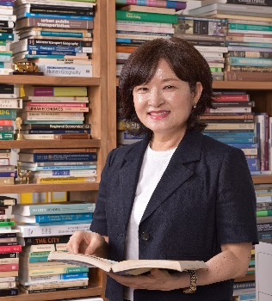

Hub of ‘International Networking’
for Global Experts

Shin LEE
Dean of ISUS, University of Seoul

Welcome to ISUS. In the midst of rapid urbanization during the process of compressed economic growth, our country has accumulated unique experiences and know-how in the urban development and administration field.
Such urban growth of the Republic of Korea has helped gain the attention of many countries abroad hoping for an opportunity of sharing the experience.
Meanwhile, although our construction companies have won a high reputation in infrastructure development such as road, harbor, and plant construction, the turning point for a qualitative take-off has become necessary as the competition with other development-pursuing countries intensified.
Like so, having the domestic and foreign demand into consideration, providing a comprehensive solution relative to the urban development and management with our experience and know-how’s and opening the way to the comprehensive package of urban development for the whole world has become a national agenda
that we must pursue. During the process, we anticipate further overseas expansion of the Korean construction companies by the development of new modules.
The University of Seoul, which pioneered through the research and education of urban-related fields, has met such demands of the current era by establishing the International School of Urban Sciences with the goal of fostering global city professionals in 2012. On one hand, we educate domestic city professionals so that they will be able to advance towards overseas urban development and management fields, and on the other hand,
we provide foreign public officials the opportunity to learn and experience Korea first-handedly by managing the International Urban Development Program (IUPD). In addition, our graduate school will be the platform on which domestic professionals and foreign public officials cultivate global insight by interacting with each other and creating an international network.
The ISUS is committed to establishing itself as the center of research and international cooperation in the area of urban sciences.
We expect your continued interest and support.
Thank you.

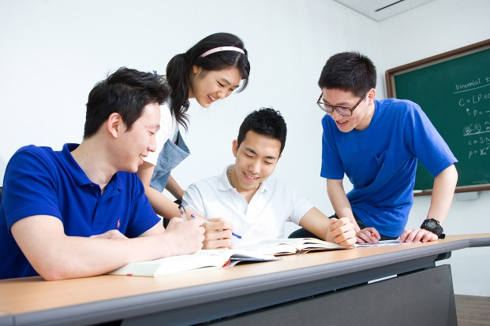
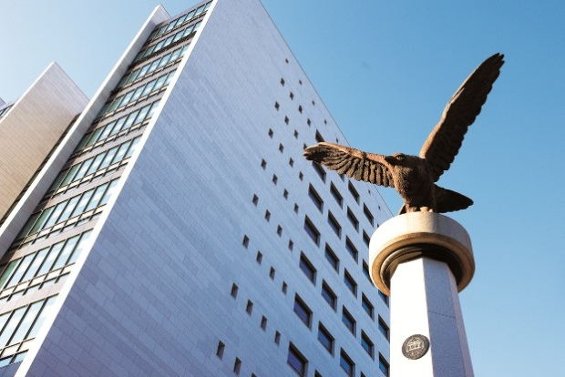
University of Seoul was founded in 1918 and has provided higher education opportunities for the intelligent, motivated, and creative scholars. As a public institution, University of Seoul is committed to addressing the social, regional, technological, and creative issues of the urbanized world. It has thus dedicated itself to cultivating leaders who will shape the urban future of Korea and the world. Its faculty, students, and administrative body are also distinguished by a commitment to civic values and a dynamic urban civilization.
University of Seoul insists on quality and breadth. It is committed to both theory and practice, and endorses openness towards students and Korea's noticeable institutions. With more than 10,000 students enrolled, University of Seoul consists of seven undergraduate colleges and almost 90 fields of study in the Graduate School. With diverse and specific programs that integrate research and policy, practice and education, University of Seoul seeks a balance between academic and professional concerns, between visionary goals and practical research. Along with basic research, University of Seoul functions as a think-tank in formulating and supporting the major policy goals of the Seoul Metropolitan Government.
In this sense, the International School of Urban Sciences has maintained a dominant position in a field of urban sciences. These range from environmental and civic engineering, architecture, urban planning and landscape design to public law and administration, taxation science, economics, urban sociology and management. With Korea’s largest and finest group of human and informational resources focused on the future of the world’s city, it boasts a unique array of research institutions working on the solutions to its problems and creative visions for its future.
University of Seoul,
The Birthplace of Korea’s Urban Study

Part II PROGRAM OVERVIEW

▣ Program Name: Master’s Program for Future Global Leaders in Environmental Policy
(MGLEP)
▣ Degree: Master of Sustainability and Environmental Policy
▣ Duration: February, 2026 ~ December, 2027 (2 years, including the preliminary program)
▣ Objectives:
- To provide future leaders of our partner countries with an opportunity to study graduate program on environmental policy and related fields at a prestigious Korean university
- To enhance program participants’ knowledge and experiences in the field of environmental policy and sustainable development
- To improve program participants’ capacity to develop and manage public policies on sustainable development
- To provide program participants with opportunities to develop cooperative relationships and personal networks with scholars, professionals, and government officials from Korea and other countries.
▣ Hosting Institution: International Urban Development Program (IUDP), International School of Urban Sciences(ISUS), University of Seoul(UOS)
▣ Language: English
▣ Cost and Financial Assistance: Full-ride scholarship with a monthly living allowance will be provided to cover the cost of attendance for the program. The cost of attendance includes the followings:
- Tuition & Dormitory fees
- Economy class, round-trip airfare between Seoul and the Participant's home country
- Monthly living allowance based on KECI regulations
- Others: medical checkup, other official event expenses etc.

▣ Application Eligibility
- Be citizens of the partnering countries designated by the Ministry of Environment of the Republic of Korea
- Be government officials or a public sector’s employee whose work is closely related to environmental policy or sustainable development (three or more years of experience required, permanent employee only)
- For employees of public organizations and institutions nominated by his/her government, a letter of nomination from the Ministry as well as the organization of the applicant’s affiliation are both required
- Hold a Bachelor’s degree officially recognized by the government as of the date of arrival to Korea
- Have a good command of both spoken and written English
- Not have participated in any of the Korean government’s scholarship programs (Master’s degree or higher) before
- Official English test score required and must be submitted(e.g., TOEIC, TOEFL, IELTS, etc.)
- Have adequate health, both mentally and physically, to stay in a Korea for an extended period of time (under the age of 40 years preferred)
- Agree to return to his/her home country after completion of study under this program
- Meet the selection conditions of universities

Part III HOW TO APPLY

1. APPLICATION/ADMISSION PROCEDURE
a. Admission Procedure
- 1st Round : Evaluation of Application Documents
- 2nd Round : Online Interview
※ Note: An online interview will be conducted only for those applicants who have passed the 1st Round (Application Evaluation). The interview will be conducted in English.
b. Application & Registration Schedule
Procedure | Admission Schedule for Spring 2026
Application deadline | By Oct. 31, 2026
Document Review | By Nov. 13, 2026
Online Interview | Nov.23-27, 2026
Final Admission Decision | By Dec. 25, 2026
Arrival in Korea | By Feb., 2027

※ Please note that the dates are subject to change. All dates are in Korean Standard Time (KST)

c. Application Requirements
1. Applicants must apply through official webpage, www.mglep.net/apply
2. All forms and documents have to be submitted and uploaded on time through official webpage, www.mglep.net/apply.
3. All of the following application materials should be sent to University of Seoul directly.
Address : #412, Law School Building, 163 Seoulsiripdae-ro, Dongdaemun-gu, Seoul, Republic of Korea
Postal Code : 02504
Receiver : Sharon BAEK
Contact : +82-2-6490-5159
- MGLEP Application Form (Form1)
- Personal Statement (Form 2)
- Statement of Purpose/Study Plan (Form 3)
- A Letter of Recommendation (Form 4)
- Letter of Nomination 1) the Minister of the Ministry or 2) the Head of the Organization of the Applicant’s Affiliation (Form 5)
- Signed document of Participant’s Guidelines (Form 6)
- Certificate of Graduation of Undergraduate and Graduate School (Applicants must submit either the apostilled or embassy notarized document)
- Official Transcripts of Undergraduate and Graduate School
- Official Report of English-Proficiency Test (TOEFL/TOEIC/IELTS) or any proof of applicant’s English-Proficiency. The test results must be issued within two years from the application deadline.
- Certificate of Employment
- Curriculum Vitae
- A Copy of Passport (If the passport has yet to be issued, please send a photocopy of national ID card. As soon as the passport is issued, please send a copy of the passport)
- Two photos, 3X4 cm or passport size with white-colored background
- Medical Results: (Included form 1)
  - Chest X-ray (TB Test)
  - Document confirming 2nd dose of Measles Vaccination

  Important Notes for All Applicants:
- All forms should be completed in English and typed and all the supporting documents should be in English as well. Documents in any other language should be accompanied by a notarized English translation.
- Documents must be apostilled or notarized by the embassy when submitted. Should they be unavailable, however, copies must be authorized by the originating institution before they are submitted.
- If any of the submitted materials contain false information, admission will be rescinded.
- Applicants whose forms and supporting documents are incomplete or unsatisfactory will be disqualified from the admission process.
- Applicants should take full responsibility for any disadvantage due to their mistakes or omissions in the application process.
- All applications must be typed, not hand written.

Part IV | PROGRAM CONTENTS

1. ACADEMIC SCHEDULE

Semester | Academic Schedule
Preliminary Session  (Feb 10~21, 2027) | Feb 10 ~ 21 | Preliminary Session(Online):  Orientation for UOS Life, Course Registration
1st semester  (Mar 2-June 25, 2027) | Mar 2 | Beginning of Semester (Required Credits: 16)
Summer Break  (June 26~Aug 31, 2027) | June 26 ~ Aug 31  Late August  Aug 23 ~ 27 | Internship  MGLEP Workshop (To be determined)  Course Registration
2nd Semester  (Sep 1 ~ Dec 17, 2027) | Sep 1 | Beginning of Semester (Required Credits: 17)
Winter Break | Dec 22 ~ Mar 1 | Matching Thesis Advisor and Student
(Dec 22, 2027 ~ Mar 1, 2028) | Dec 22 ~ Feb 22  Late February  Feb 22 ~ 25 | Internship  MGLEP Workshop  Course Registration
3rd semester | Mar 2 | Beginning of Semester (Required Credits: 12)
(Mar 2 - June 20, 2028) | Early July | Comprehensive Exam
Summer Break  (June 21- Sep 1, 2028) | Late June  Late August | Thesis Proposal Presentation  MGLEP Workshop
4th Semester | Late October | Interim Thesis Exam (Pt & Review)
(Sep 4 - Dec 23, 2028) | Late November | Final Thesis Exam (Pt & Review)
Pre-departure period  (Dec 22 - Dec 31, 2028) | Dec 3  Dec 10 ~ 15  Dec 10 ~ 15 | Thesis Submission to library  Completion Ceremony  Departure
* The above schedule is subject to change. A detailed program schedule will be provided upon arrival.

a. Preliminary Session (2 Weeks)

Students are required to take a 2-week preliminary session before the first academic semester begins. The preliminary session is designed to help students adjust successfully to the program. Issuing foreign registration card, medical checkup and Korean cultural experiences, etc. will be done aside from the coursework.

a – 1. Orientation
After arrival in Korea, an orientation will be held for the students. The orientation aims to provide participants with useful information on the program as well as general information on living in Korea that the participants will need during the program. The orientation will include:

- Introduction to the Master’s Program for Future Global Leaders in Environmental Policy (MGLEP)
- Introduction to the International Urban Development Program (IUDP) and UOS
- Overview of Academic Affairs
- Introduction of Student Support and Services
- A Seoul City Excursion
- Registration for Identification
- Open a Korean bank account
- Medical Check-up etc.

(*) The medical check-up will be implemented after arrival in Korea to assure participants’ health condition. If any case including AIDS or pregnancy which may hamper their graduate study in Korea is found by the medical check-up, the participant will be required to return home. The acceptance to the MGLEP and the acquirement of the status of scholarship recipient will be confirmed after medical check-up.

b. Regular Coursework Semesters (3rd semesters)
Students are required to complete 51 credit hour coursework during regular academic semesters. During the Winter/Summer Session, an internship or job shadow opportunity may be offered to enhance the students’ practical understanding of urban and regional development. After completing the course work, students are required to pass a thesis submission qualification exam.

c. Thesis Writing Session (4th semester)
After completing the required coursework, students will be required to write a Master thesis under the guidance of his/her advisor. Interim thesis draft will be tested on two thesis presentation sessions, where participants will present his/her thesis draft to be evaluated by thesis committee members.

2. CURRICULUM

a. Curriculum

The coursework consists of 24-credit core coursework and 12-credit elective courses excluding thesis course and internship program. Students are required to take more than 51 credits for graduation.
Course  Classification | Course Title
Core Courses  (7 courses) | 21 Credits
Core Courses  (7 courses) | Global Project DevelopmentⅠ (3)
Core Courses  (7 courses) | Environmental Policy (3)
Core Courses  (7 courses) | Resource Economics (3)
Core Courses  (7 courses) | Korea Environmental Policy Seminar (3)
Core Courses  (7 courses) | Environmental Impact Assessment (3)
Core Courses  (7 courses) | Data Analysis for Environmental Research (3)
Core Courses  (7 courses) | Environmental Research Thesis Seminar (3)
Elective Courses  (11 courses, choose 5) | 15 Credits
Elective Courses  (11 courses, choose 5) | Global Project DevelopmentⅡ (3)
Elective Courses  (11 courses, choose 5) | Environment and Climate Change (3)
Elective Courses  (11 courses, choose 5) | Seminar on Development Studies (3)
Elective Courses  (11 courses, choose 5) | Resource Circulation Policy (3)
Elective Courses  (11 courses, choose 5) | Renewable Energy Policy (3)
Elective Courses  (11 courses, choose 5) | Water Resources Management (3)
Elective Courses  (11 courses, choose 5) | Climate Change and Disaster Management (3)
Elective Courses  (11 courses, choose 5) | Introduction to Environmental Engineering (3)
Elective Courses  (11 courses, choose 5) | E-Government (3)
Elective Courses  (11 courses, choose 5) | International Cooperation and Social Sustainability (3)
Elective Courses  (11 courses, choose 5) | Transport and Sustainable Urban Development (3)
Thesis  &  Internship | 7 Credits
Thesis  &  Internship | Thesis Writing (6)
Thesis  &  Internship | Internship Program (1)
Language | 8 Credit
Language | Basic KoreanⅠ& II (4)
Language | Academic WritingⅠ& II (4)
Total | 51 credits
*The above courses and credits are subject to change.
b. Required Grade Point Average (GPA)

- Students with a GPA below 3.0 for two consecutive semesters will be automatically expelled from the program.
- Minimum cumulative GPA for graduation within the 16 months of resident is B0 (3.0/4.5). Students with a GPA below 3.0 will be disqualified from acquiring a diploma or a graduation certificate.

c. Thesis Writing

- Prospective students are required to submit their policy research topics in the application process. An academic advisor will be assigned for the student based on his/her research topic once the student is admitted. The academic advisor will serve as the chair of the student’s thesis guidance committee.
- Each student should organize his/her thesis guidance committee in consultation with his/her academic advisor. The guidance committee should consist of 2~3 members including the academic advisor and 1~ 2 additional guidance committee members.
- The student must provide the members of guidance committee with a thesis proposal. The student will begin writing the thesis during the 3rd semester after the thesis proposal has been approved by the committee.
- All students are required to submit their thesis to their guidance committee and the dean of ISUS at least a week prior to the defense date, and successfully defend their thesis by the end of the 4th semester.

3. EXTRACURRICULAR ACTIVITIES

a. Field Studies

1) Site visits and field trips

- The program will arrange four site visits which can help students gain more practical knowledge of Korea’s environment policy and its efforts for sustainable development.
- The site visits will also include cultural activities which can help students better understand Korean culture and society.
- The program offers opportunities to learn exemplary practices in mediating the environmental impacts of urbanization and industrialization and Korea’s efforts in responding to climate change.
- Field activities are subject to external conditions such as the weather, the pandemic, or other emergency policies at the national, local and University level.

2) Seminars

The program offers opportunities to learn exemplary practices in mediating the environmental impacts of urbanization and industrialization and Korea’s efforts in responding to climate change.
Field activities are subject to external conditions such as the weather, the pandemic, or other emergency policies at the national, local and University level.

b. Internship/Job Shadow Opportunities

The program may provide internship opportunities for the students to gain more practical knowledge of Korea’s environment policy and its efforts for the sustainable development at cooperating institutions, subject to the availability of internship places at the hosting agencies. The students may have a chance to do an internship/job shadow during the winter/summer break session. Students can take advantage of this internship opportunity and seek professional advice and collect data for thesis writing from the institutions where they do their internship.

c. Events

- Welcoming Ceremony and Orientation
- Sports Day
- Seminars, Forums, and Conferences
- Cultural Events

Part V | ACADEMIC INSTITUTION

- GENERAL OVERVIEW OF UNIVERSITY OF SEOUL (UOS)
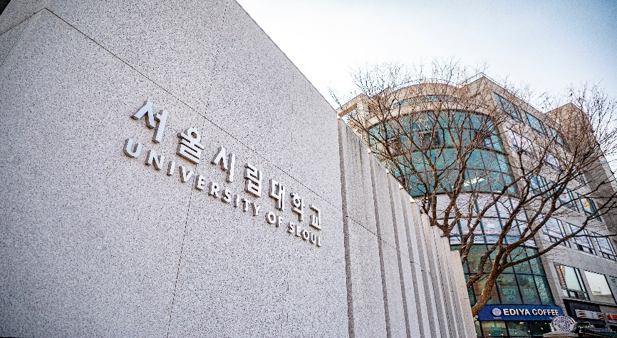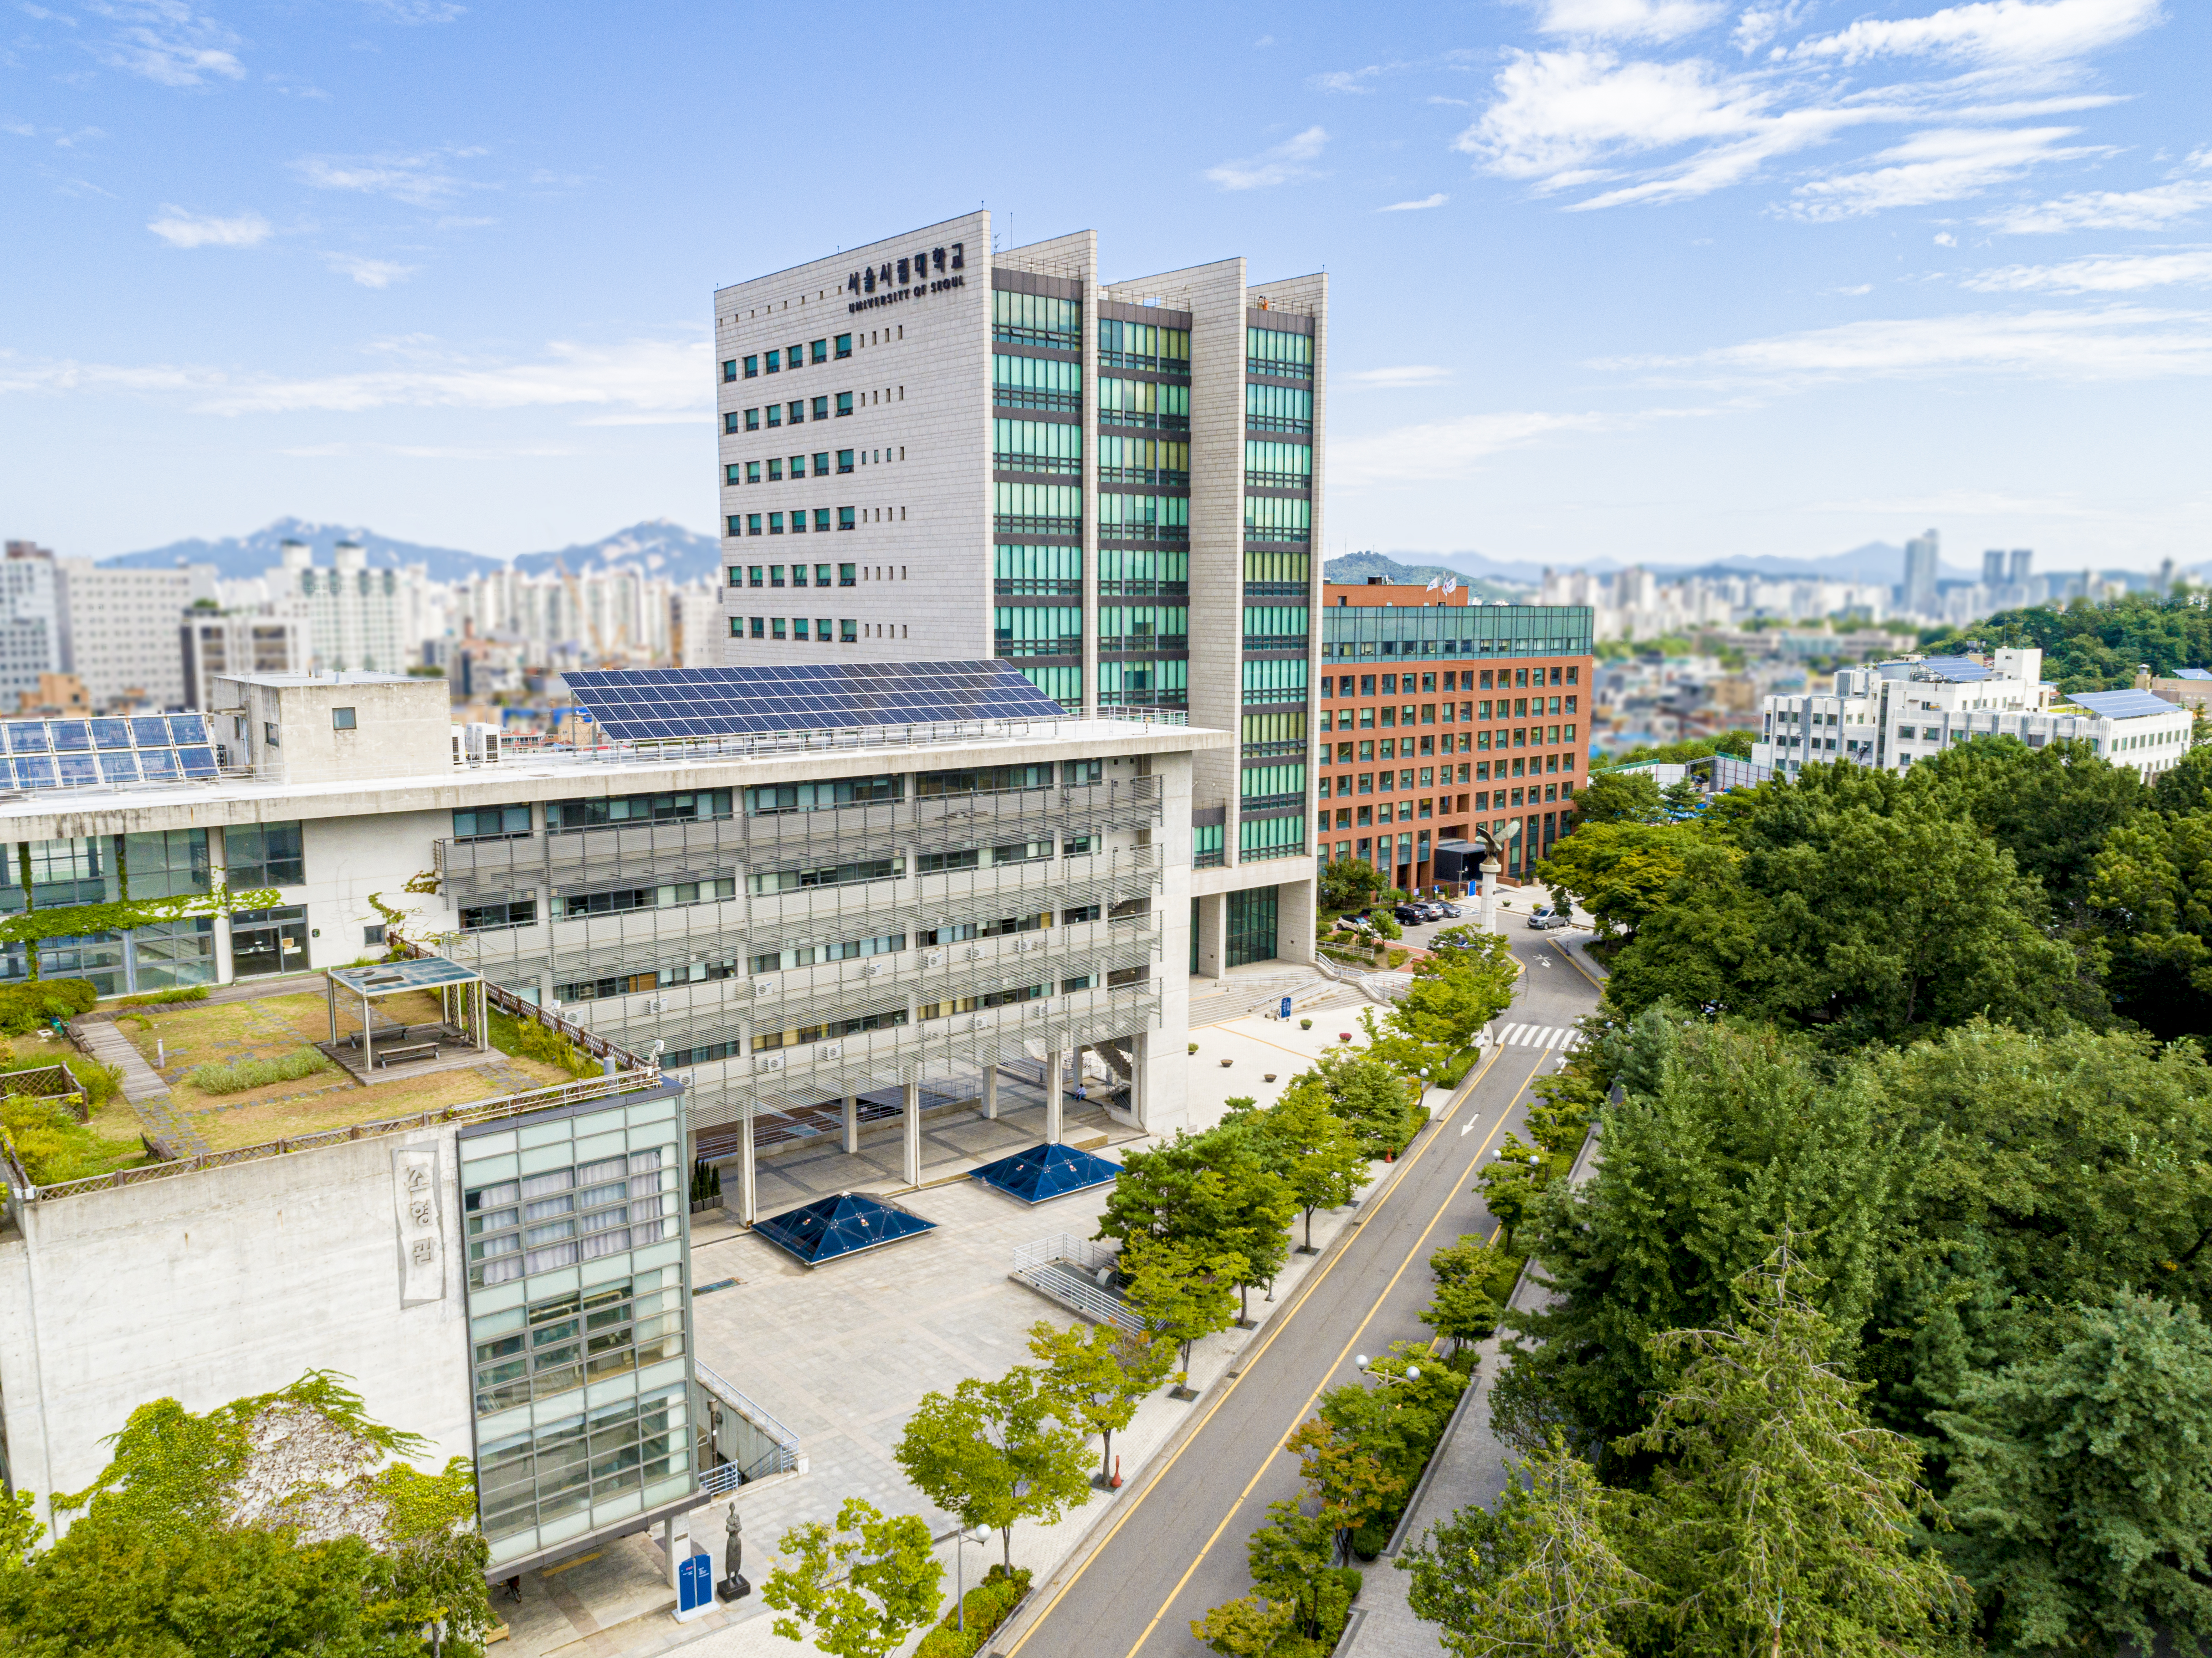
University of Seoul is a public university funded and supported by the Seoul Metropolitan Government. Seoul is the economic, political, and cultural center of Korea. It is also the 600-year capital of Korea, a historical city with social, cultural, and physical layers spread out along a vast and complex landscape. The character of the university, academic programs, and research institutions is shaped by Seoul’s metropolitan dynamic. Its faculty, students, and administrative body are distinguished by a commitment to civic values and a dynamic urban civilization. Along with basic research, it functions as a think-tank in formulating and supporting the major policy goals of the Seoul Metropolitan Government. With diverse and specific programs that integrate research and policy, practice and education, the University of Seoul seeks a balance between academic and professional concerns, between visionary goals and practical research.
University of Seoul has set a clear goal of becoming an international center for the urban sciences. These range from environmental and civic engineering, architecture, urban planning and landscape design to public law and administration, taxation science, economics, urban sociology and management. More recently, the university has diversified this base to include the arts and humanities. In the area of science and engineering, the university has concentrated on the development of information and media technology. With Korea’s largest and finest group of human and informational resources focused on the future of the world’s city, it boasts a unique array of research institutions working on the solutions to its problems and creative visions for its future.
For more information, please visit https://english.uos.ac.kr/.

- INTERNATIONAL SCHOOL OF URBAN SCIENCES (ISUS)
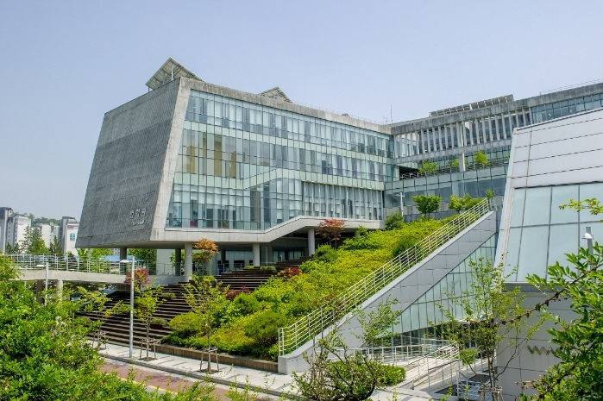
International School of Urban Sciences (ISUS) at University of Seoul (UOS) was launched in 2012 in an effort to contribute to the development of sustainable urban communities in the world. It covers diverse fields of urban sciences including urban and regional planning, infrastructure development, construction development, and environmental policy.
ISUS offers two graduate programs for Korean students: global construction management and sustainable urban & regional development. In order to reinforce international cooperation and educate global experts, ISUS also hosts four Master’s degree programs in cooperation with partner organizations: Master of Urban Administration and Planning (MUAP) in collaboration with Seoul Metropolitan Government, Master of Urban Development (MUD) with Korea International Cooperation Agency (KOICA), Master's Program for Future Global Leaders in Environmental Policy (MGLEP) with Ministry of Environment, and Master's degree in Urban Development and Smart Infrastructure Policy (MUDSIP) with Ministry of Land, Infrastructure and Transport. These full scholarship programs are expected to contribute to the sustainable development in partner countries by providing the academic and professional skills necessary for their home countries.
Korea is an exemplar which has transformed from one of the poorest countries in the world to a developed economy for the last half century. Its unique experience makes it a source of lessons learned that can be shared with global community. ISUS is committed to reinforcing professionalism in the area of sustainable urban and regional development by sharing Korea’s experience. In this global platform of knowledge exchange, participants will get theoretical and practical knowledge and foster global perspectives through mutual learning process with their classmates from around the world. These sponsored graduate programs are expected to contribute to the sustainable urban development in developing countries by providing the academic and professional skills necessary for their home countries.
- University of Seoul(UOS): http://www.uos.ac.kr/en/
- International School of Urban Sciences(ISUS): http://isus.uos.ac.kr/
- ISUS Facebook: https://www.facebook.com/ISUSatUOSofficial
- ISUS YouTube: https://www.youtube.com/@isusuos6698/featured
- ACCOMMODATION

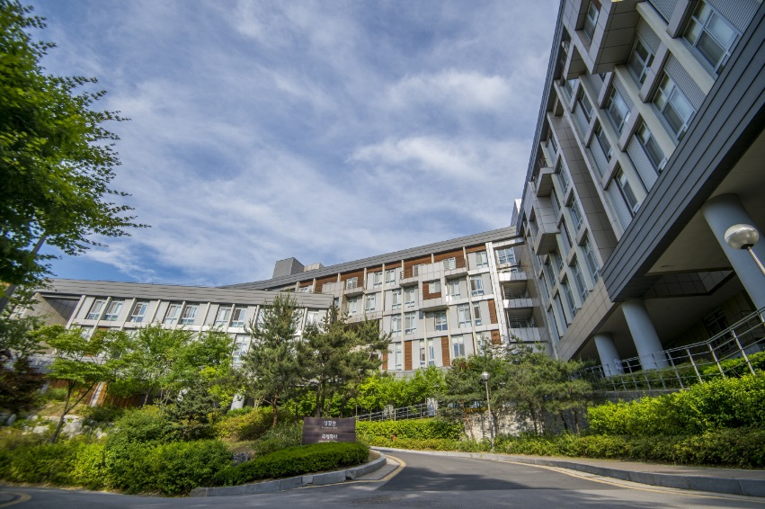
Students will reside at the dormitory of UOS, and rooms will be assigned every semester. The university’s on-campus housing facilities, the Dormitory and International House has Korean students and international students, so that living on campus allows students to meet new friends and experience all that UOS campus offers through various living, dining, and campus life options. Room types vary between single, 2-person and multi-person room. The assignment of the room is centrally administered by the UOS Dormitory Office.

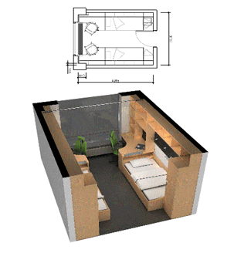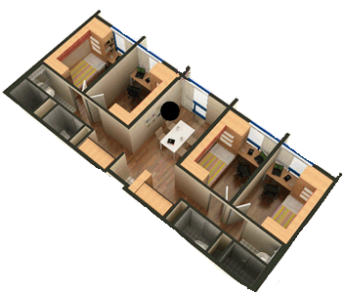
<Picture: Rooms in the International House>
All rooms are fully equipped with central heating, central air conditioning and free LAN internet access. The rooms are centrally air-conditioned but students can set the room temperature using the control switch. The electric voltage in Korea is 220V (60hz), and the standards wall socket has two rounded holes. Due to fire hazard reasons, any cooking device that results in fire is strictly prohibited in the room. The dormitory has a community kitchen for students to cook their own food occasionally. Many international students use this community kitchen to cook their own ethnic food and share it with other international or Korean students.

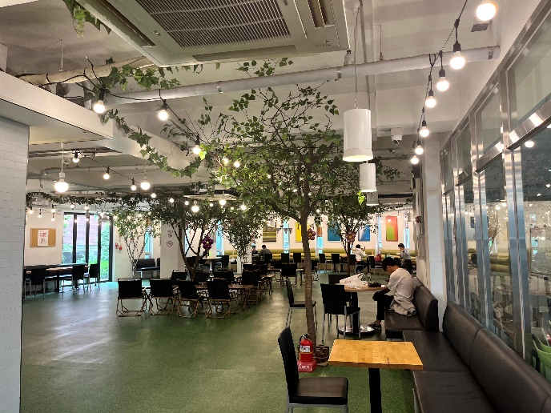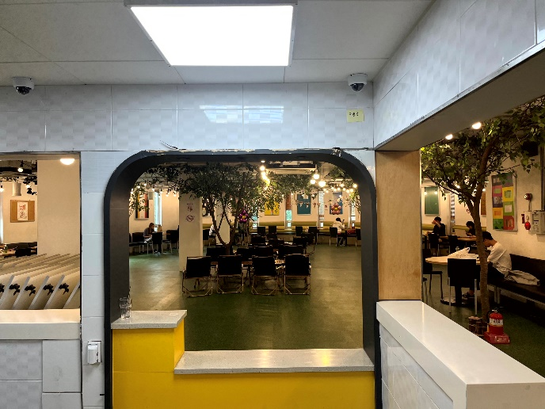
<Community Kitchen & Cafeteria>
The Dormitory and International House provides coin-operated laundry rooms and a gym for its residents’ use. These are located on the basement floor and open 24 hours. Seminar rooms, student lounges, and an internet café are also available for the residents.
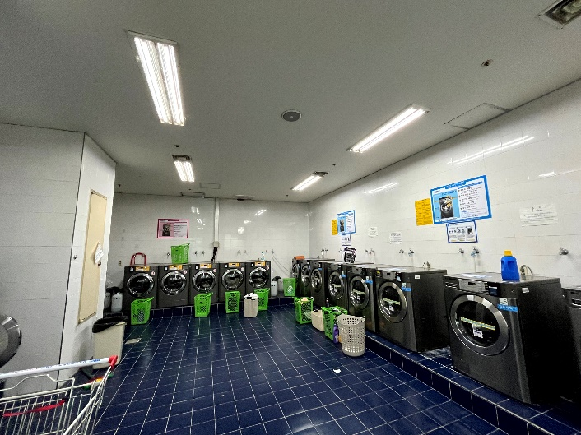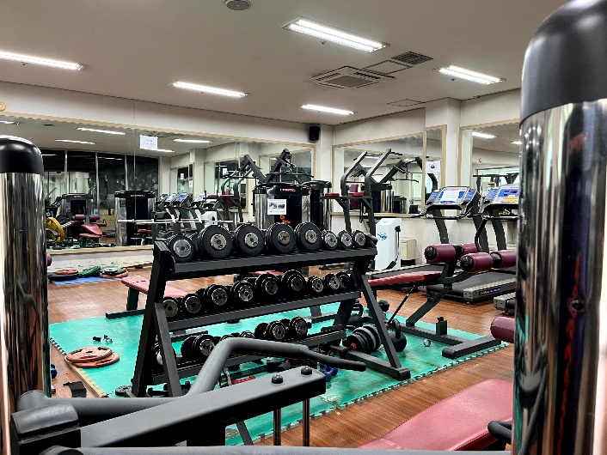
<Laundry Room and Gym>
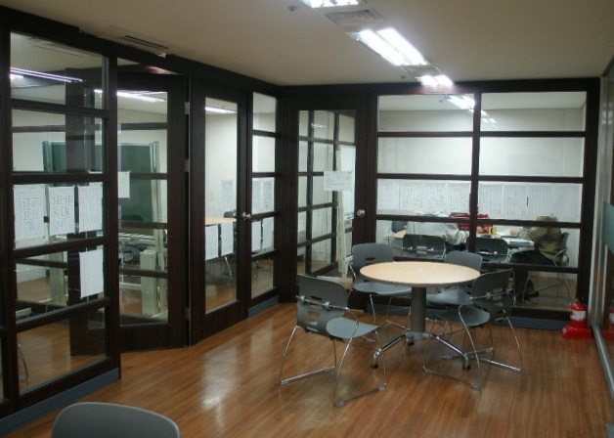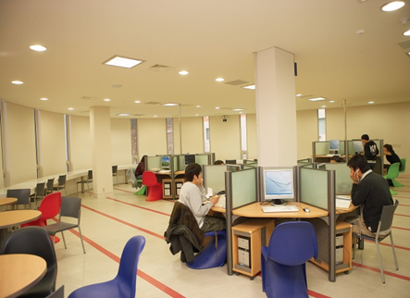
<Seminar Rooms>
• Certificate of Health All of the residents have to submit the certificate of health, TB test, to the Dormitory Office. (Every participant has to take a medical check-up upon arrival in Korea. The medical check-up report may replace the certificate of health.)
• Dormitory Bedding Bedding and pillows are not provided; participants need to prepare their own blankets and pillows (Bedding materials can be purchased at the nearest store from school).
• Automatic Face Recognition System On your first day, you will have your photos taken at the dormitory office in order to be registered for dormitory access.
• Laundry You may do laundry after you buy a laundry card and charge it.
• Cooking Cooking is allowed at the Community Kitchen
• Residence Separation Each female and male dormitory is out-of-bounds from each other.
• Usage of Electricity The authorization of electric goods may vary as mentioned below. In case of using prohibited electric goods, the goods will be seized with penalty points imposed to the user.

Type | Goods | Allowed? Yes or No
Heating equipment | Electric blanket | NO
Heating equipment | Electric linoleum | NO
Heating equipment | Electric heater | NO
Heating equipment | Fan heater | NO
Cooking equipment | Boiler | NO
Cooking equipment | Coffee maker | NO
Cooking equipment | Toaster | NO
Cooking equipment | Microwave | YES, UNDER PERMISSION
Cooking equipment | Electric frying pan | NO
Cooking equipment | Gas burner | NO
Cooking equipment | Electric rice cooker | NO
Cooking equipment | Hot plate | NO
A/V equipment | VCR | NO
A/V equipment | TV | NO
A/V equipment | Electronic instrument | NO
Learning equipment | Desk lamp | YES
Learning equipment | Lap top | YES
Learning equipment | Printer | YES
Other equipment | Fan | NO
Other equipment | Refrigerator | YES, UNDER PERMISSION
Other equipment | Mini air-conditioner | NO
Other equipment | Vacuum | YES
Other equipment | Hair dryer | YES
Other equipment | Mobile Charger | YES

* Kindly double check if your electronic goods are 220V-60Hz in case of fire or any electricity accidents.

- OTHER INFORMATION

- University Library
The University of Seoul Libraries are dedicated to serve for the academic success of all UOS community members. The UOS Libraries are composed of the main library and the following two branch libraries
- Law Library
- Economics and Business Administration Library
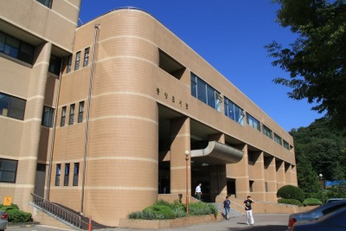
Main Library
The Main Library is composed of reading rooms with 2,200 seats and houses almost 800,000 volumes of books, monographs and references. It also holds 1,466 different periodicals, 58,034 units of non-book materials and several online databases.
The Main Library opened the Digitalized Information Service Room in 1998, which allows users to access more non-book materials.
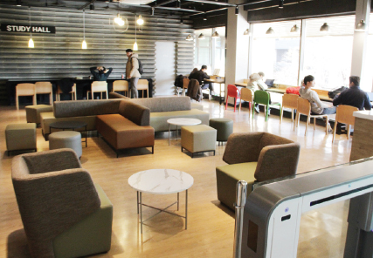
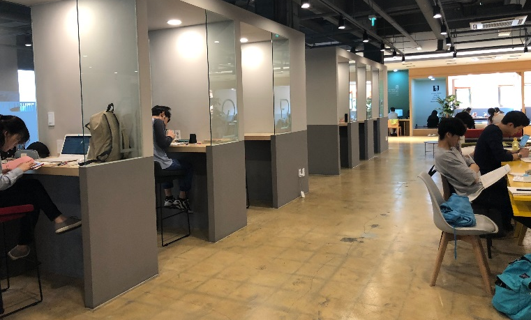
The expanded and computerized library system enables users to confirm, check, renew, reserve, check-out, purchase and send orders via the internet. In 1999, the Main Library reached an agreement with the National Assembly Library for the mutual exchange of academic information through the internet, thus facilitating access to vast amounts of information.

The Main Library also provides printing services for the full-text database of social science theses and dissertations. Most recently, the Main Library has created a new program which allows users better access to information on research resources, and has established the Integrated Retrieval System to facilitate easier access to multimedia data and e-books.
Law Library
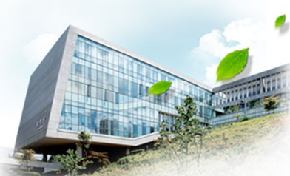
The law library was established as a branch of the UOS Libraries with a legal resource room, a postgraduate reading room, and information retrieval equipment in Floors 4~6 on October 2008. The library has 80,705 legal books (as of January 13, 2011) in 1,600㎡ to support research activity, lecture, legal information investigation for the Graduate School of Law and legal area. On the 4th floor, it has group study rooms, an IT room, a laptop section and a lounge. On the 5th floor, it has a postgraduate reading room, an IT room and a preservation library. There is a legal study resource room including periodicals, reference books and articles on the 6th floor.
Economics and Business Administration Library
The economics and business administration library was established as a branch with reading rooms, group study rooms and seminar rooms in Floor 3 on March 2011. The library has over 20,000 books, 70 periodicals and 15 database in 1,036.8㎡ to support the research and learning activity of professors and students in management and economics. It has a 24 seat resource reading room, free reading rooms (148 seats), 5 study rooms (30 seats), a seminar room (8 seats), and information retrieval equipment (11 seats) to provide best service.

- Computing Facilities
Many computer labs are available in UOS. In Korea, IBM is more widely used than MAC. The most accessible places to the Internet are the Student Lounge on the first floor in the 21 Century Building and Main Library. If you bring a laptop, you can access the Internet in your dorm room with the LAN cable which you need to prepare by yourself.
- Printer, Photocopy Machine and Scanner IUDP office is equipped with 1 computer, 1 printer, 2 photocopy machines for students’ use.

- Bank and Money Exchange
Woori Bank is located on the first floor of the Main Building. The business hours are from 9:00 to 16:00, Monday through Friday and it closes on weekends and holidays. During the preliminary session, students will fill out the application form to open a bank account.
Foreign currency can be exchanged into Korean currency (won) in banks at the airport, foreign exchange banks, and other authorized money exchange places including the on-campus Woori Bank. Please note that only US Dollars, Euros, Japanese Yens and Chinese Yuans can be exchanged on-campus bank. Global ATM can be found easily in Seoul. There is one right next to Woori Bank on campus.

- Student Cafeteria and Snack Bars
There are several cafeterias and snack bars on campus. They all serve different menus to meet the need of students and faculty.
  - Student Cafeterias
Student Cafeterias are located in the Student Hall, Natural Science Building and in the dormitory. Korean dishes and western dishes are available. Prices normally range from KRW2,500to KRW6,000 won per person and it subjects to the menu of the day. The cafeterias run from 11:00 to 14:00 for lunch, from 17:00 to 19:00 for dinner on weekdays, and are closed on weekends and holidays.
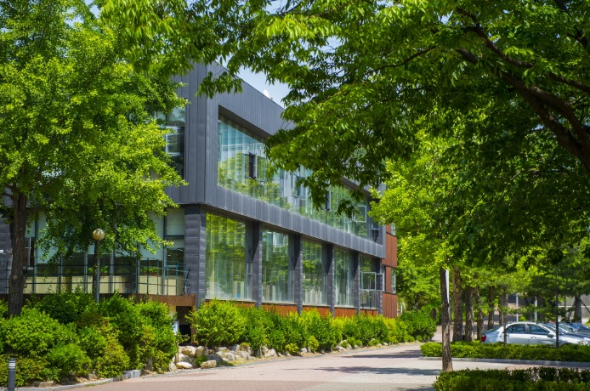
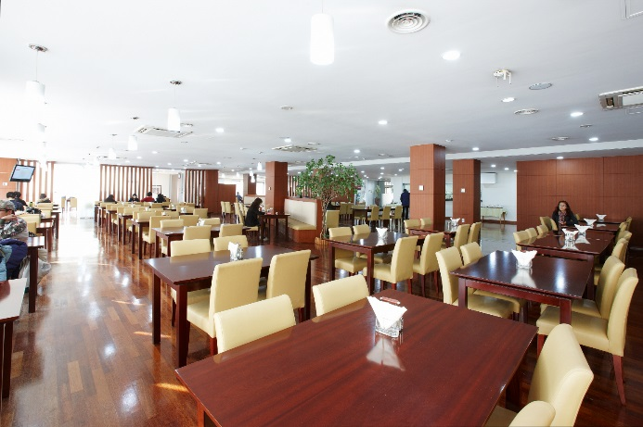

  - Snack Bars
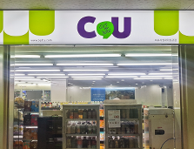
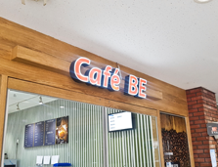
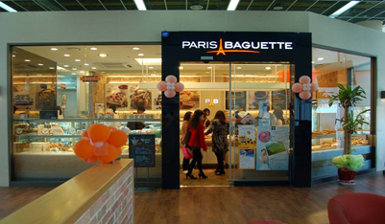
Several snack bars and cafes are also available in the Student Hall and other buildings on campus.

- Convenience Stores
Location | Floor | Convenience Store | Opening Hours  (during semesters)
Location | Floor | Convenience Store | Weekdays | Saturdays
Student Hall | B1 | CU | 08:00-22:00 | Closed
Main Library | B1 | CU | 08:00-22:00 | 08:00-22:00
Dormitory | 2 | CU | 07:00-24:00 | 07:00-24:00
*Opening hours during vacation may differ from above.

- Student Cafeterias
Location  (bldg.no) | Floor | Cafeterias/  Restaurants | Menu | Opening Hours  (during semesters)
 |  |  |  | Weekdays | Weekends
Student Hall  (#12 on the map) | 1 | Student Cafeteria | Korean Meals | Lunch 11:00-14:00  Dinner 17:00-19:00 | Closed
Student Hall  (#12 on the map) | 2 | Annekan | Western Style Meals | Lunch 11:30-14:00  Dinner 15:00-18:30 | Closed
Natural Science Building  (#8) | 1 | Student Cafeteria | Korean Meals | Lunch 11:30-13:30  Dinner 17:30-18:30 | Closed
Cheonnong Hall  (#1) | 1 | Cheonnong Café | Drinks and Desserts | 08:30-20:00 | Closed
Main Library  (#21) | 1 | Café Booktopia | Drinks and Desserts | 08:30-19:00 | Closed
100th anniversary bldg.(#17) | 1 | Paris  Baguette | Bakery | 08:30-20:00 | Closed

- Health Services
The University Health Service Center is located on the 2nd floor of the Student Hall. (Open from 9:00 to 18:00 except Saturday and Sunday) Examination, prescription and medicine for simple illnesses such as cold or indigestion will be offered without cost. On every Wednesday between 14:00~16:00 (exception of vacation), Campus physician is available.
- On Campus Health Services University Health Service Center is located on the 2nd floor of Student Hall (#12 on the campus map). Examination, prescription and medicine for simple illnesses such as cold, indigestion and cuts will be treated free of charge.
- Office Hour: Mon.-Fri., 09:00-18:00(12:00-13:00, Lunch Break)

- Off-campus Hospitals
- Samyook Medical Center (삼육서울병원)
Sundays & Weekdays: 09:00-17:00, Fridays: 09:00-12:00
Contact: 1577-3675

- Seoul Sungsim General Hospital (서울성심병원)
Weekdays: 09:00-17:30(12:30-13:30, Lunch Break), Saturdays: 09:00-13:00
Contact: 02-966-1616

- Post Office
The post office is located on the first floor of the Natural Science Bldg. The campus post office provides general mailing services including mail, parcel, registration, domestic and international EMS. The business hours are from 9:00 to 18:00

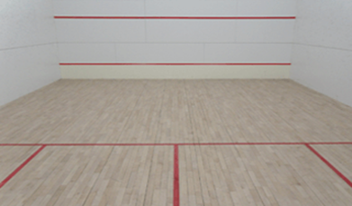
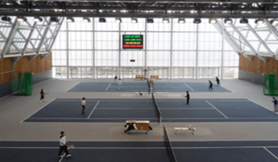
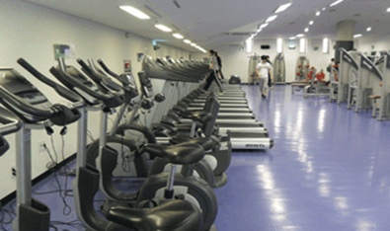
- University Gymnasium and Wellness Center
As a place for general physical education, the University Gymnasium and Sport Complex is used for instruction as well as for various sports and recreational activities. Various indoor and outdoor sport facilities and equipment are provided for such sports or recreational activities. The sports center has a fitness room and it costs 20,000 Won per a month. Some other facilities in the Gym include indoor tennis courts and squash courts.

- Wi-Fi Service
Wi-Fi service is available within the campus. In order to have access to it, students are required to create an ID and PW on the university website and log on to the mobile or laptop device with the log-on information. Preferentially, students may directly visit the Computational Intelligence Service Office.
- Office Hour: Mon.-Fri., 09:00-18:00 (12:00-13:00, Lunch Break)
- Location: 5th floor, University Center (#7 on the campus map)

- Student ID Card
The Student ID card is mainly used for library, entering the building, checking-out & returning books, etc. It will be ready for pick-up at the IUDP office from the second week of the semester.

- Foreigner’s Registration
All foreigners planning to stay in Korea for more than 90 days must report to the Seoul Immigration Office and register for the Alien Registration Card within 90 days from the date of arrival. To be eligible for the Alien Registration, students should hold a long-term D-2 visa. Alien Registration will be done during the preliminary session and students will be accompanied by the program coordinator to the immigration office. It takes about a month to have the Alien Residence Card issued.
- Required documents:
- Alien Registration Form
- Certificate of Enrollment
- Passport
- 1 ID photo
- Registration fee: KRW35,000(Fees may increase, and please be prepared)

Map of University of Seoul

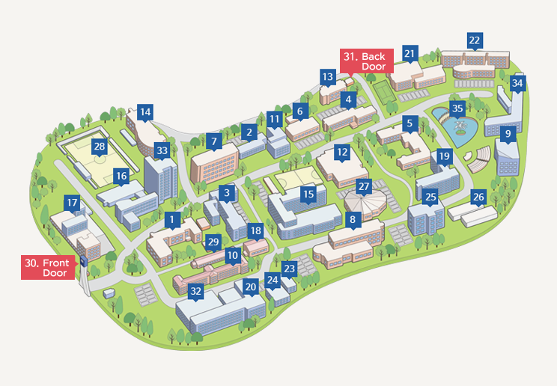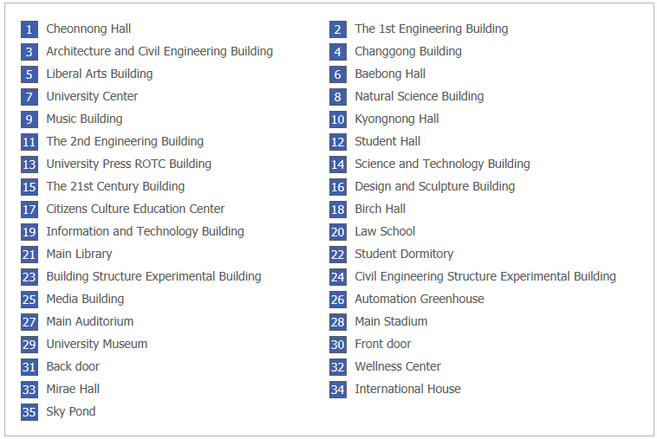

Part VI SUPPORT SERVICE

1. TRAVEL TO KOREA

UOS is financially responsible for the participant’s travel to and from Korea. The participant is to travel by the most direct route between Incheon International airport and a main international airport in participant’s home country. UOS will cover economy class, round-trip airfare.

If a participant wants to change the flight itineraries, the additional fare should be borne by him/her. The participant is responsible for the issuance of a visa necessary for this Scholarship Program.

If a participant invites family members for a temporary visit during the program on vacation periods, he or she must take the full responsibilities for all the relevant costs and other necessary administrative procedures (please refer to the “4. Accompanying or Inviting Family” Section of Part 7. Regulations).

2. EXPENSES FOR STUDY AND LIVING

The following expenses will be covered by KECI-UOS during the participant’s stay in Korea.

- Tuition & Dormitory fees
- Living allowance (including meals): KRW 999,000 per month
- Economy class, round-trip airfare between Seoul and the Participant's home country
- Miscellaneous travel expenses: KRW 200,000 upon arrival
- Others: A medical checkup after arrival, field trip expenses, etc.

3. MEDICAL SUPPORT AND INSURANCE

    - Medical Check-up
Medical Check-ups will be provided two times throughout the duration of the program.
1st Check-Up: Upon arrival in Korea, in order to check the medical conditions before joining the Program.
If the medical check-up result shows that it is inadequate (i.e., pregnant, HIV-positive and other contagious diseases) for applicant to stay in Korea for a long time as a student, the acceptance to the program will be cancelled and the applicant will be asked to return to his or her country.
2nd Check-Up: Medical Check-up for student health during the program. If the medical check-up result shows that it is inadequate for applicant to stay in Korea for a long time as a student (i.e., pregnant, HIV-positive and other contagious diseases), the acceptance to the program will be cancelled and the applicant will be asked to return to his or her country.
The 2nd check-up will be conducted 6 months before student’s return to his or her country.
If the student wants additional check-ups, the check-up fees will be borne by the student.

    - Insurance
UOS provides participants with medical insurance, both Governmental National Health Insurance and Private Medical Insurance.

National Health Insurance Program
The National Health Insurance Corporation (http://www.nhic.or.kr/portal/site/eng) provides health insurance for foreign students. The insurance is designed for overseas Koreans and foreigners who stay in Korea for more than a year. Foreign students, their spouses and their children under 20 are eligible for the insurance. To apply, the student must submit a copy of his/her alien registration card and verification of his/her purpose of stay at an office of the Corporation.

Information of National Health Insurance(NHI)
Type | Contents
Eligibility | - A foreigner who has intentions to stay in the Republic of Korea for more than one year with D-2(Student) Visa, and her/his spouse and children under 20 (F-3).  - A foreigner will be automatically registered for the NHI after the Alien Registration certificate is issued.
Application Documents | - Verification of Eligibility including Alien Registration Card  - Verification of Purpose of Stay  (A copy of Alien Registration Card or a copy of Residence Certificate)  - Verification of Income (If the applicant has income)
Premiums | - The insured is subject to pay from the first day of Alien Registration  - The insured is subject to pay during temporary leave within 1 month.  - In the case of a temporary leave longer than one month, the insurance is cancelled on the next day of departure, and the student must renew it upon return.
How to use the service | Since you are already enrolled in the National Health Insurance, any medical expenses incurred at hospitals or clinics are paid at a discounted rate, as the insurance coverage is automatically applied.
Payment | Monthly pre paid by the MGLEP admin office

Private Medical Insurance
With private health insurance coverage, students may receive treatment at clinics or hospitals and are required to pay the full cost upfront in the event of illness or injury. Afterward, they can submit a claim for reimbursement.
The insurance typically covers items such as accidental death and disability, medical expenses due to accidents, and medical expenses related to sickness.

    - Insurance Provided by the Institution
The details of the private insurance provided by the institution will be introduced during the course orientation upon arrival.

Part VII REGULATIONS

1. PARTICIPANT’S RESPONSIBILITIES

- Participants are required:

  - To abide by the rules of the academic institution
  - To take up the scholarship in the academic year for which it is offered (deferral is not allowed)
  - To reside in the accommodation designated by UOS for the duration of the course except for holidays or temporary leave
  - To maintain an appropriate study load and achieve satisfactory academic progress for the course. If the participant fails to attain certain grades required by UOS, his or her status as a MGLEP program participant may be suspended
  - To participate in all activities associated with the approved course of study including all lectures and tutorials, submit all work required for the course and sit for examinations unless approved otherwise by UOS in advance
  - To advise UOS of any personal or family circumstances such as health problems or family problems which may seriously affect their study
  - To refrain from engaging in political activities or any form of employment for profit or gain.
  - To agree to KECI collecting information concerning them and passing that information onto other relevant parties, if necessary
  - To return to their home country upon completion of the program
  - Not to extend the length of the program or stay for personal convenience; neither KECI nor UOS will provide any assistance and be responsible for an extension of their stay
  - To either return to their original job post or remain employed in a field related to their degree for at least 2 years.
- If the participants break any of the rules of either KECI or UOS during their stay in Korea, their status as MGLEP program participant may be suspended or terminated.
- UOS may cancel the admission if a participant fails to take a medical check-up.

2. WITHDRAWALS

- In principle, a participant is not allowed to withdraw from the course at his or her own option once the course starts.
- A participant may withdraw with valid personal or other pressing issues from one’s home country (such as health or work issues) when acceptable to KECI-UOS.
- If a participant fails to attain certain grades required by UOS, he or she may be forced to withdraw and return home upon withdrawal.
- The participant who withdraws must return to UOS the living allowance he or she has already received for the remaining period from the date of departure from Korea.

3. TEMPORARY LEAVE

- In principle, participants are not allowed to take temporary leave during semester. In case of special circumstances e.g. his/her own marriage, death of family, participants can take temporary leave after they notify the university in advance. They should notify the Program Chair and the UOS office prior to the departure by submitting the “Request for a temporary leave” document. The e-ticket should also be submitted when issued.
- Participants those who wish to take temporary leave during summer/winter vacation, one must submit relevant documents (academic petition form, flight ticket etc.) 2 weeks prior to their departure date, and must return at least 1 week before the semester starts.
- In case of traveling to other countries, they are additionally required to submit a traveler’s insurance for the travel period.
- KECI and UOS do not pay airfare for the trip. KECI will not pay the living allowance for the absent days including departure date and arrival date.
- In the month of temporary leave, the monthly allowance (KRW 999,000) will be calculated based only on the number of days the student resides in Korea. KRW 33,300 will be provided per day of residence during that month.
- All expenses incurred for participant’s temporary leave should be covered by the participant, not by the KECI and the University of Seoul
- If the participant is found to have made an unreported temporary visit to his or her home country or traveled to other countries or made a trip without university’s approval, his or her living allowance will be suspended (from the day of departure to the day of return), and UOS may impose a disciplinary action on them, including expulsion from UOS.

4. ACCOMPANYING OR INVITING FAMILY

- As MGLEP Program is quite an intensive program which requires students of full commitment to and concentrated endeavors for study, participants should not accompany any family members during the study period.
- Participants may invite family members within a month to the fullest, only during the semester break. However, they must be able to cover all the relevant expenses such as airfare, accommodation, living cost, visa fee, insurance, etc. of their family as well as be responsible for any administrative procedures required
- UOS or KECI is not responsible for issuing any invitation letter regarding this matter.

5. OTHERS

- KECI -UOS will assume responsibility only within the limit and scope of the insurance for participants.
- KECI -UOS is not liable for any damage or loss of participant’s personal property.
- KECI -UOS will not assume any responsibility for illness, injury, or death of the participant arising from extracurricular activities, willful misconduct, or undisclosed pre-existing medical conditions.
- Participants are advised not to purchase or own personal vehicles due to safety concerns and concentration on their studies.

Part VIII | CONTACTS

❏ International School of Urban Sciences (ISUS), University of Seoul

- Phone: +82-2-6490-5159 / +82-2-6490-5157
- Fax: +82-2-6490-5141
- E-mail: mglep@uos.ac.kr
- Home page: www.mglep.net, http://isus.uos.ac.kr
- Address: #412, Law School, University of Seoul,
163, Seoulsiribdae-ro, Dongdaemun-gu, Seoul,
Republic of Korea, 02504

❏ Korea Environmental Conservation Institute (KECI)

- Phone: +82-2-3406-2523
- Fax: +82-2-3409-8352
- E-mail: ehgjs02@keci.or.kr
- Home page: https://www.keci.or.kr/web/main.do
- Address: YD B/D 320-2, Gwangnaru-ro, Seongdong-gu,
Seoul, Republic of Korea, 04799

